**Project Development – Delivery plan sprint-4**

IoT Based Safety Gadget for Child Safety Monitoring & Notification

**TEAM ID:** **PNT2022TMID02457**

**Creating the MIT app and Showing the child's location**

**Create App in MIT App inventor:**

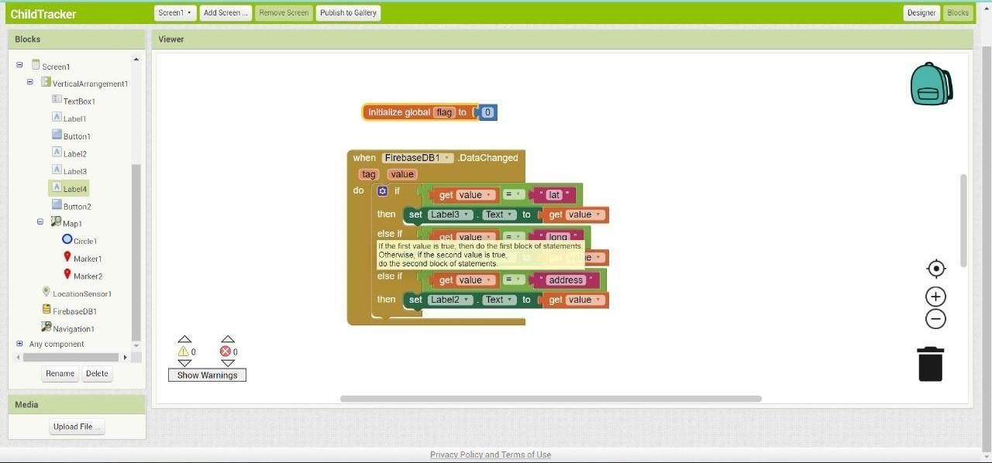

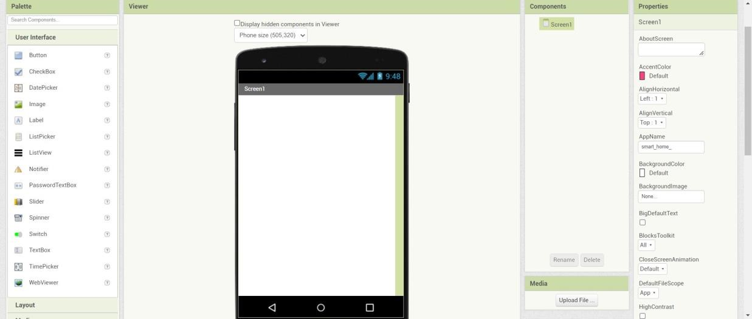

**Block Configuration:**

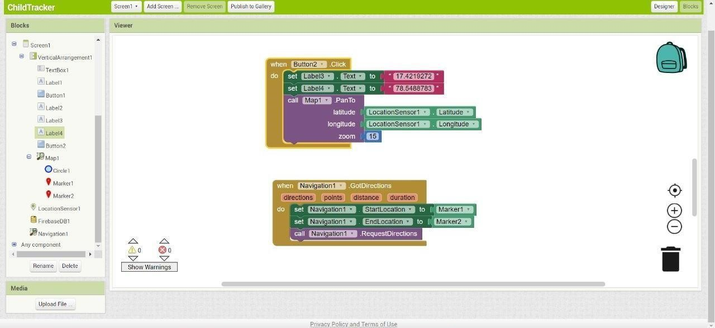

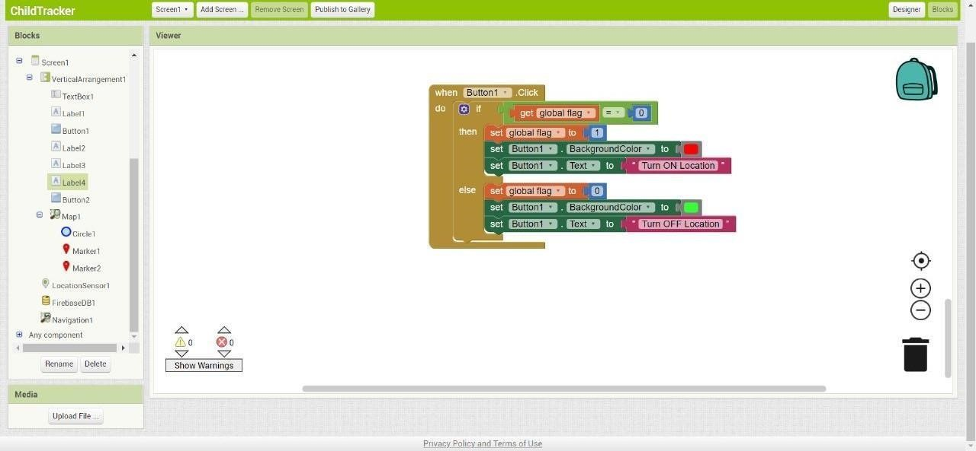

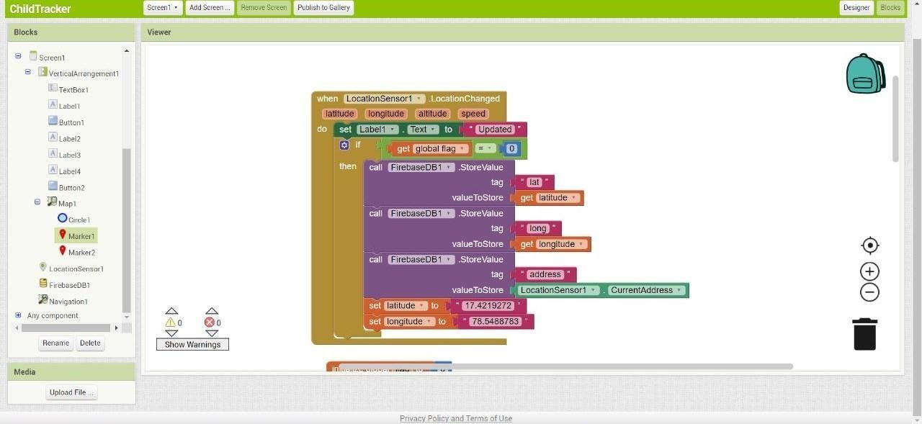

**Output(App inventor):**

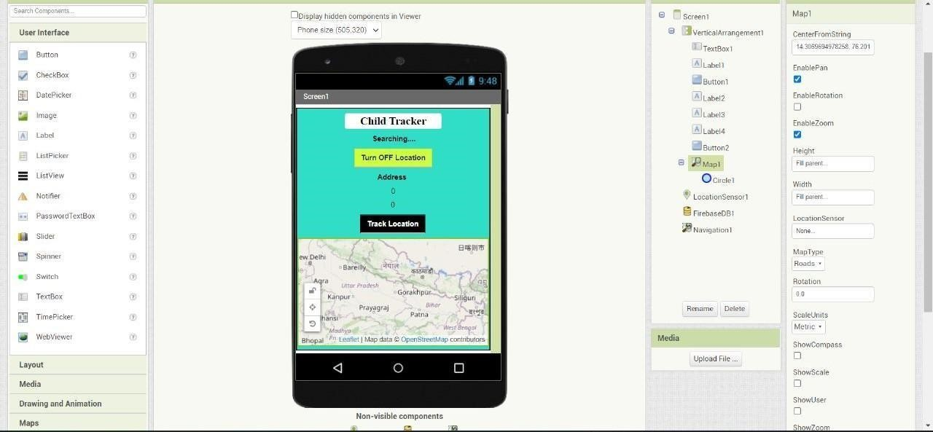

**Location Status:**

